How I mounted my 23” FoamFloats to a GWS Slow Stick

By Jeff Charlot

I’ve always wanted a floatplane, and I love my Slow Stick, it just seemed natural to buy some floats and mount them. But how? I’m sure there is a better way, but this is how I did mine.

First, I assembled the floats according to the directions, with a couple of changes. I can’t seem to leave well enough alone. I used three pieces of strapping tape on the bottom instead of one. I live in Alaska and these will be my snow skis as well, so I felt the extra reinforcement was necessary.
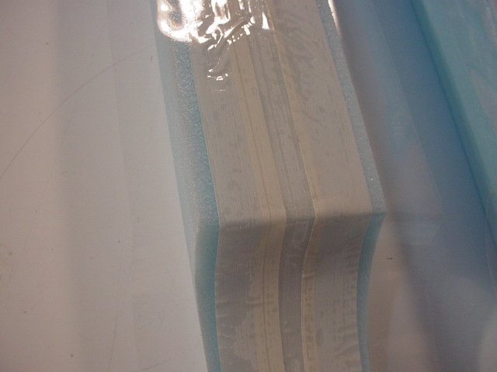
Next I measured where I wanted the mounting lugs to be located according to the manufacturers recommendations. The forward lug was centered at 7 ¼” from the front of the float. The rear lug was centered 4 ½” from the rear of the float. I felt that placing them on top of the float was unattractive, so instead I cut small holes and epoxied them in the foam, flush with the surface.
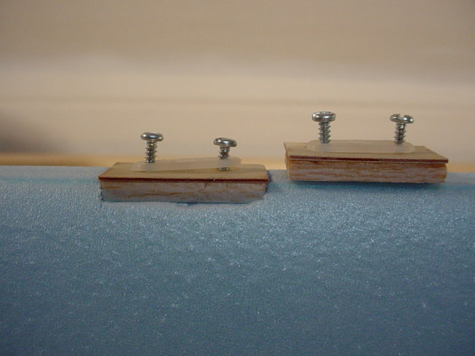

For mounting the floats to the Slow Stick, I decided to use the existing landing gear brackets/mounts and basically copied the whole landing gear. Not real original, but it is quick and easy to swap out landing gear and floats. The piano wire is bent to the correct shape for inserting in the brackets, then the forward gear is clipped at 9 ¾ inches and the aft gear at 10 ¾”. (Later changed to match the front) This allows you to bend a small “axle to insert under the straps. The idea being to provide a small “tip up” aspect while in flight. The forward strut is pushed in the forward bracket. The tail wheel is removed from the tail wheel bracket and is then slid up the fuselage until it almost meets up with the aft wing hold down bracket. Then the aft strut is simply slid in, in place of the tail wheel. Simple!

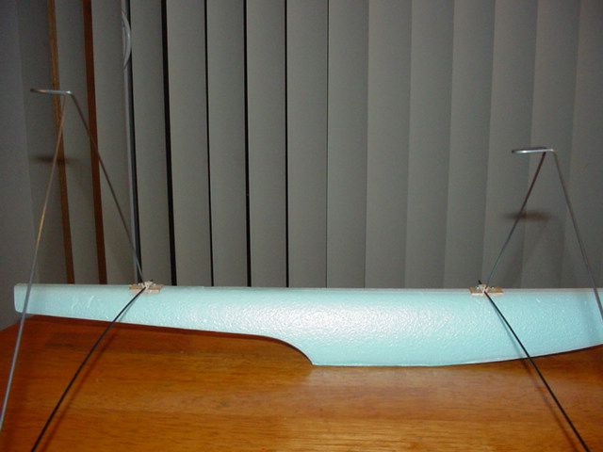

Now for the test float, I found that these measurements were close as far as balance on the floats, but I was still a little tail heavy. Also, the “tip up” aspect idea was a failure. It caused the Slow Stick to have a nose down attitude while floating. It also made taxiing a little nerve wracking.
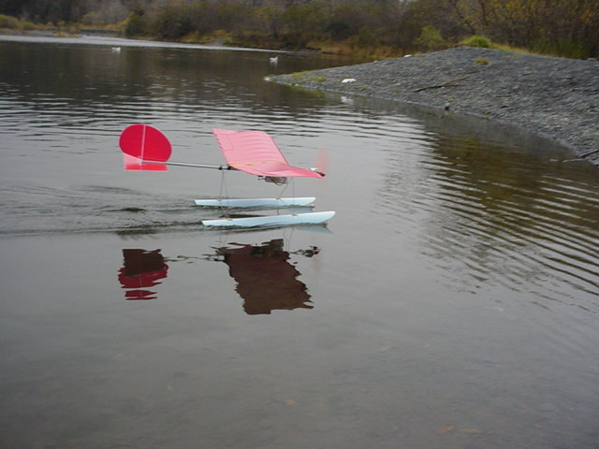

So back to the shop. I clipped the rear gear to be an equal height to the front, then looked at the balance issue. The Slow Stick rides a little tail heavy and should be moved forward on the floats. The only way to get it “spot on” will be to cut the mounts out of the floats and reinstall them farther forward, probably around the 6 - 6 1/2” mark. I’m not sure I’m willing to do that. So back to the pond to check aspect and balance again.
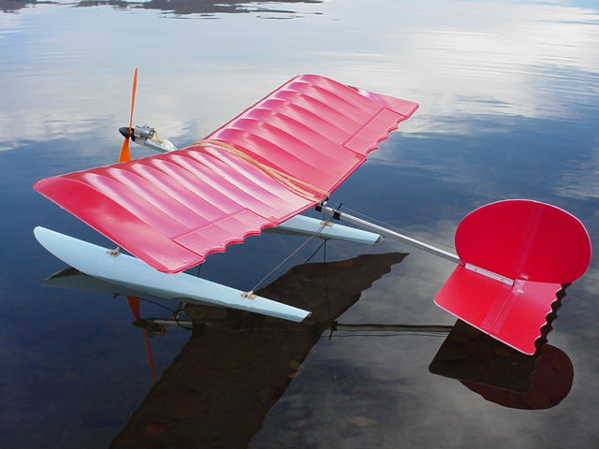
Well, it didn’t actually improve or get worse; it just changed, definitely sitting a little lower in the tail. Let’s try power on.

Yup, that’s it! When power is applied, the drag created by the floats causes the plane to almost instantly level out. When more power is applied, take off is within 5-10 feet with a fresh charge. The Slow Stick has plenty of power, long take off runs are not necessary. Power up, wait to come up on step, (2-4 feet) a LITTLE up elevator, and the plane breaks free very quickly.

In flight handling is unremarkable. It’s a little draggier than the wheeled version, yet more stable due to the lower center of gravity. On the last picture you can see a line I attached from the front cross brace, pulling the floats aft a little. Neat experiment, but it didn’t work. I’m back to the original design. In all fairness, I mounted my floats too far forward. If something were to happen to this set, I would mount the plane on them farther forward. As it is, I LOVE flying off of water. Touch and goes in the street are fine, splash and goes in a pond are GREAT!! Thanks Will for making floats accessible to all of us. Now, some pix to tempt you!

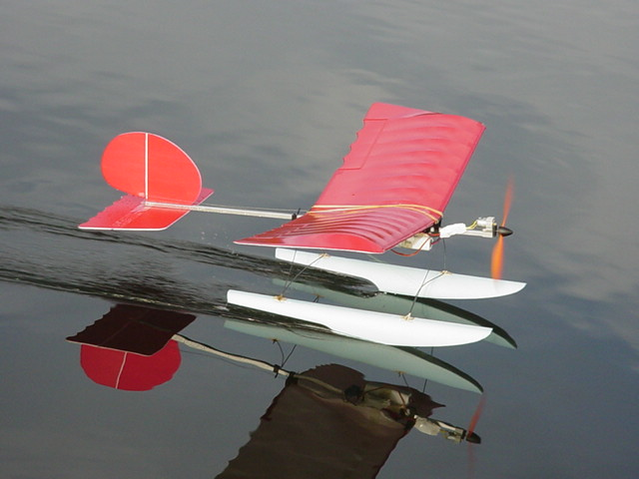

Jeff Charlot
Kodiak, Alaska

